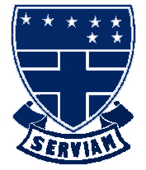
St Ursula’s Convent School
A Humanities College and Teaching School

ADMISSIONS CHECK LIST

Have you:

Stated St Ursula’s Convent School as a preference via the Local Authority’s Common Application Form (CAF)

Completed St Ursula’s Convent School’s Supplementary Information Form (SIF) including Section B about Religious Practice and had it signed and stamped by your Parish Priest

Provided original evidence of your daughter’s Baptism? (i.e. certificates)

Provided evidence of both parishes attended (if applicable)

Please note the deadline for receipt of applications is 30 October 2020
Applications by Friday 23 October 2020– (before the Half Term holiday) is recommended

- Please return Common Application Forms (CAF’s) to your Local Authority

- Please return Supplementary Information Forms (SIF’s) to St Ursula’s Convent School

Thank you

