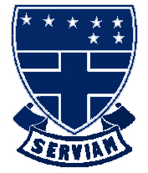
St Ursula’s Convent School
A Humanities College and Teaching School

ADMISSIONS – Evidence of Baptism

Please fill in the information requested below and post it to the SCHOOL together with your daughter’s ORIGINAL Baptism certificate or evidence of reception into the Catholic Church. Please include also a stamped address envelope for their return.

Alternatively, you may bring the certificate to the main school office where it will be photocopied and returned to you at once.

Please print

DAUGHTER’S SURNAME ______________________________________________

DAUGHTER’S FORENAME_____________________________________________

DATE OF BIRTH _____________________________________________________

DATE OF BAPTISM ___________________________________________________

CURRENT PRIMARY SCHOOL _________________________________________

PARENT / CARER’S NAME_____________________________________________

ADDRESS _________________________________________________________

___________________________________________________________________

POST CODE _________________________________________________________

TELEPHONE_________________________________________________________

EMAIL ______________________________________________________________

Please tick as appropriate

BAPTISM CERTIFICATE ENCLOSED YES  NO 

Signed _________________________________ Date ______________
(Parent/Carer)

